Bahria University,

Karachi Campus



LAB EXPERIMENT NO.

___01___

LIST OF TASKS

|  |  |
| --- | --- |
| TASK NO | OBJECTIVE |
| 01 | Make a 5 page website, including home page, linked altogether having header and footer section mandatorily. Web pages should cover all the html tags overall eg : make a gallery page with the help of table tag and insert images in that. |
|  |  |
|  |  |
|  |  |

Submitted On

28-09-2023

(Date: DD/MM/YY)

**Task 01:** Make a 5 page website, including home page, linked altogether having header and footer section mandatorily. Web pages should cover all the html tags overall eg : make a gallery page with the help of table tag and insert images in that.

Topic for the website can be anything. No css required.

Make sure to use all tags mentioned in slides.

**Solution:**

**index.html:**

    <center>

    <header>

        <ul>

            <li><a href="index.html">Home</a></li>

            <li><a href="/contact.html">Contact Us</a></li>

            <li><a href="/about.html">About</a></li>

            <li><a href="/gallery.html">Gallery</a></li>

        </ol>

    </header>

    <h1>This is my website "codingshub.com"</h1>

    <img src="./codingshub.png" alt="codingshub">

    <footer>

        <h3>Footer</h3>

        <a href="emailto:shoaibakhter181422@gmail.com">Email Me</a>

        <a href="/contact.html">Contact US</a>

    </footer>

</center>

</body>

**contact.html:**

    <h1>Contact US</h1>

    <form action="">

            <label>Name</label>

            <input type="text">

            <label >Father Name</label>

            <input type="text">

            <label >Phone Number</label>

            <input type="number">

            <label >Email</label>

            <input type="email">

            <label >Massage</label>

            <input type="text">

    </form>

**about.html:**

    <h1>Introduction</h1>

    <p>I am Shoaib Akhter. I want to become a Software Engineer.</p>

    <h2>Introduction to Bahria University</h2>

    <p>Bahria University Karachi Campus is one of the good University</p>

**gallery.html**

<h1>Gallery Page</h1>

<table border="2">

<tr >

<td bgcolor="red"><img src="../codingshub.png" alt="codingshub" width="50%" height="50%"></td>

<td bgcolor="green"><img src="../sun.jfif" alt="sun" width="50%" height="50%"></td>

<td bgcolor="yellow"><img src="../codingshub.png" alt="codingshub" width="50%" height="50%"></td>

</tr>

<td bgcolor="blue"><img src="../sun2.jfif" alt="sun2" width="50%" height="50%"></td>

<td bgcolor="pink"><img src="../codingshub.png" alt="sun3" width="50%" height="50%"></td>

<td bgcolor="grey"><img src="../sun2.jfif" alt="sun2" width="50%" height="50%"></td>

</table>

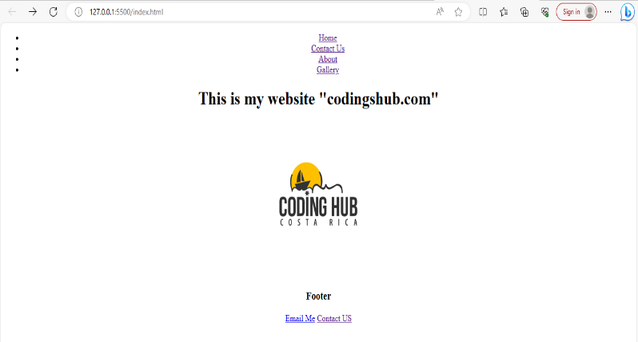**Output:**



